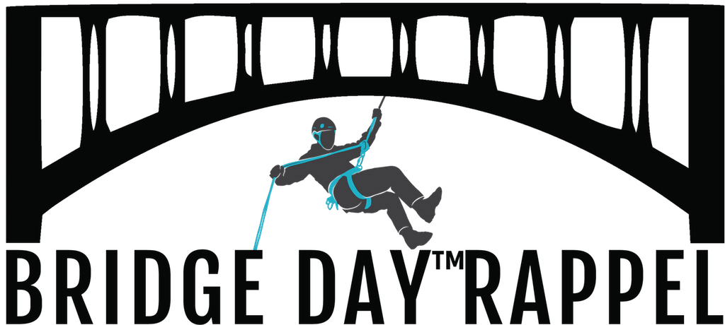
2018 New River Gorge Bridge Day™
250’ Rappel Guidelines
Individuals only!
Not a team event.

Bridge Day, Saturday, October 20, 2018
We hope that you will be able to join us this fall for the 39th Annual Bridge Day doing a 250’ rappel from the New River Gorge Bridge. The following is our timeline, registration process, fees, and other important information. Thank you!

The Bridge Day 250’ Rappel gives the general public the opportunity to be a Bridge Day participant. The first 250’ rappel off the New River Gorge Bridge was done in October 1993 when a participant from the Oprah Show did the rappel as part of the Show’s Week of Fears. Through the years, this rappel has been done for training, demonstrations, scouts, and part of Bridge Day.

The 2018 Bridge Day 250’ Rappeller will rappel from the New River Gorge Bridge’s catwalk on the north end of the Bridge to State Route 82. You will be belayed with additional safety measures as needed. Your rappel will be 250 vertical feet.

Timeline September 1-28 Please register online at www.bridgedayrappel.com,
250’ Rappel
October 20, Saturday 39th Bridge Day
9 am check in
10 am - 2 pm 250’ Rappel
Fee $195 per person plus fees
There is an online booking fee for processing your registration.

Requirements & Rules
- Rappelling can be dangerous!
- Each participant must assume personal responsibility for his/her own safety.
- You must be 18 or older and not weight more than 275 lbs. Our harness fits waist sizes 20-52”
- No experience is required.
- You must use our equipment. Helmets and gloves are required.
- You will do one rappel. You may get a 2nd rappel.
- Each rappeller will complete and sign an acceptance of risk and liability waiver releasing all people associated with Bridge Day rappelling (i.e., Bridge Day Commission, Rappel Coordinator, Safety Team, and others).
- Bridge Day is a public event. You will sign a photography release. Your picture will be taken and you have no control on how it may be shown (i.e., as a composite or as distorted in character or form). By registering to participate in the Bridge Day Rappel, you do hereby waive any right to inspect and/or approve any photos taken during the Bridge Day registration, orientation meeting, and on Bridge Day.
- The ropes will be rigged under the Bridge. Two independent anchors will be provided.
- The catwalk will be supervised and secured on Bridge Day.
- Sandals, Aussie Rappels, upside down rappel, and costume accessories (i.e., antlers) are not allowed.
- There are limited spaces and registration can be closed at a moment’s notice.
- The cost per person is $195 plus tax and fees.
- We will operate rain or shine, and there are no refunds if you change your mind, the event is cancelled, or you do not show.
- You will receive an orientation, safety briefing, be outfitted with equipment, and do a 250’rappel.
- All persons going beneath the New River Gorge Bridge are subject to a law enforcement security check.
- There is a shuttle from the landing zone back to the New River Gorge Bridge.
- There is a designated spot where people can watch you rappel. No one will be allowed to go underneath the New River Gorge Bridge with you.
- On Bridge Day, you will need to meet us on the north end of the New River Gorge Bridge.
- Warm clothes are recommended because it can be chilly on the catwalk. The catwalk can be 10-15 degrees colder than what it is roadside.
- Please be patient and not in a hurry. By the time you meet us at the booth, safety briefing, put on a harness, walk out on the catwalk, wait your turn, rappel, and get a shuttle back to the top, 2-3 hours of your Bridge Day will go by.
- The Bridge Day Rappel Coordinator is Benjy Simpson. His decisions are final. Please email benjy@bridgewalk.com with your questions and/or concerns.

We look forward to sharing with you Bridge Day, the underside of the New River Gorge
Bridge, the fall colors of the New River Gorge, and the excitement of rappelling from the
New River Gorge Bridge’s catwalk.

New River Gorge Bridge Day™ Rappel
Post Office Box 71
Fayetteville, West Virginia 25840
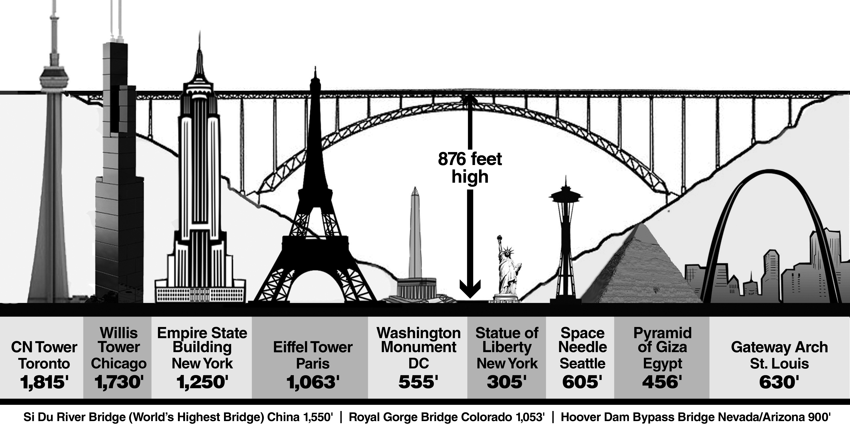
www.bridgedayrappel.com
benjy@bridgewalk.com
250’ Rappel
Disney beach

New River Gorge Bridge Facts

 longest single arch bridge in Western Hemisphere
 3rd longest single arch bridge in the world
 2nd highest vehicle carrying bridge in the US
 5th highest vehicle carrying bridge in the world
 3rd highest bridge in the United States
 13th highest bridge in the world
 on the West Virginia State quarter
 on a United States postal stamp
 listed on National Register of Historic Places
 Bridge Day celebrated 3rd Saturday every October

2018 Bridge Day 250' Rappel Guidelines JULY.doc

